Welcome to the Llantwit Major School Art and Design Department!

Here you can find information about the Art and Design department and access our department ‘padlet’ page, where you will find up to date information and examples of the learner’s fantastic work.
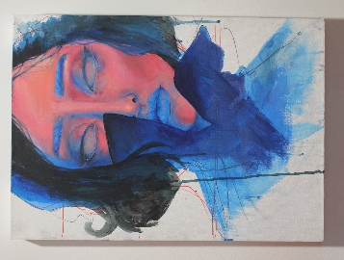
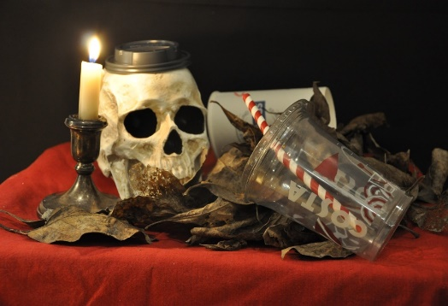
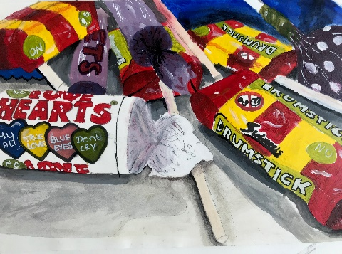
“Logic will get you from A to B. Imagination will take you everywhere.”
Albert Einstein
The Art and Design department offers a wide range of meaningful learning experiences during which learners will be physically, socially and emotionally engaged. As a result of their experiences in Art and Design learners’ well-being, self-esteem and resilience will be nurtured, in turn enhancing their self-confidence. The Art Department also fosters and builds creative and critical thinking skills which aid learners’ capacity to question, make connections, innovate, solve problems, communicate, collaborate and reflect critically. Learners at all levels are encouraged to develop projects that are personal to them and also work to find and select appropriate artists and craftspeople to research, in order to develop their contextual understanding and creative skills. The department runs an inclusive approach to Art & Design with the intentions of expanding the horizons of every learner. It is a multi-disciplinary department that runs a number of different workshops including drawing, painting, printmaking, photography and 3D design using clay, card and found materials.
We provide a range of extra-curricular activities such as the department run Art Club, workshops run by external groups and class trips to Cardiff and London, all of which enable students to gain knowledge about their own culture and society, as well as other people’s. At the end of the academic year we celebrate our exam stage student’s achievements with an exhibition of GCSE, AS and A level work and learners take part in the exhibition as exhibitors and attendees. We are a popular and lively department within the school and students in our care work extremely hard to produce exciting outcomes – as a team we are proud to support the diverse and exciting artwork they create.
Google Classroom Code
Scan the QR code using your smartphone or…
Year 7 Art and Design - ejcxont
Year 8 Art and Design - yaotnlf
Year 9 GCSE Art, Craft and Design – oxm54fk
Year 9 GCSE Photography – gbiy2nv
Year 10 GCSE Art, Craft and Design – 7k7ewz4
Year 10 GCSE Photography – kme5sxa
Year 12/13 AS/A Level Art, Craft and Design – iq4ppk4

https://padlet.com/k_donaldson1/ieszk3lrmea5
…click here to view the Art and Design department ‘padlet’ page featuring up to date news and examples of fantastic Art work created by our learners.

