Science Department

KS3 Science

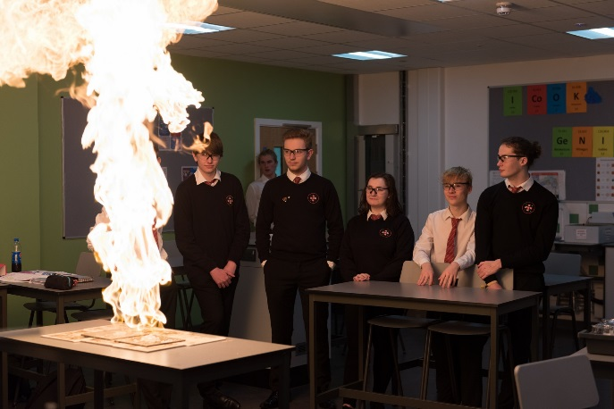
Science is compulsory for all pupils in Key Stages 3 and 4. At Key Stage 3, learners are given opportunities to build on the skills developed at Key Stage 2. They develop their skills of numeracy, communication, ICT and problem solving through the range of ‘Interdependence of Organisms’, ‘The Sustainable Earth’ and ‘How Things Work’. Emphasis is placed on ‘Active Learning’.
At Key Stage 4 the WJEC Double and Triple Award Course is offered at GCSE. This is examined in May/June of Years 10 and 11 and leads two or three GCSE qualifications in Science.
A science practical exam is taken in year 11 and accounts for 10% of all marks. The WJEC Triple Award Science course is available for our More Able and Talented students.

At Key Stage 5 AS and A Level, Biology, Chemistry and Physics are taught using the WJEC specifications; these build on students’ success at GCSE. Level 3 BTEC Applied Science is also offered to Year 12 and 13 students.

Independent research work at KS3
The department sets an independent research project for biology, chemistry and physics each term. The idea behind each task set is for pupils to choose and then complete an extended activity that links to and enhances their knowledge and understanding of topics covered in lessons.
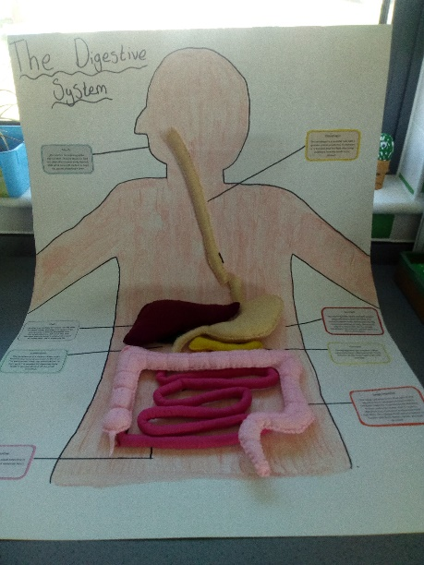
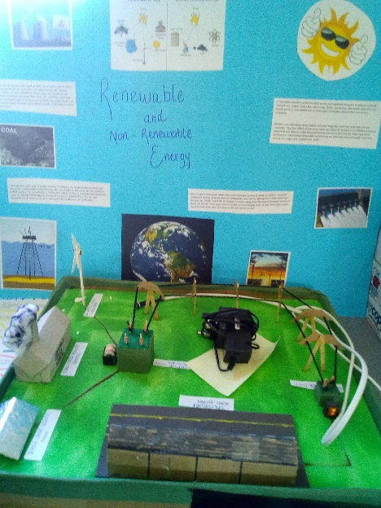
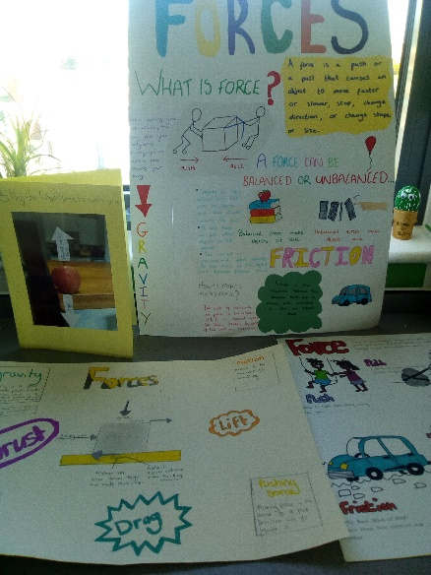
We would like to share some of the creative work with you from our talented pupils.

